RESEARCH PROPOSAL
DOCTOR IN ORAL MAXILLOFACIAL PATHOLOGY AND ORAL MEDICINE (DrOMPathMed) (2024-2027)
TITLE: A MACHINE LEARNING PREDICTIVE MODEL FOR ORAL SQUAMOUS CELL CARCINOMA (OSCC) RECURRENCE
NAVENITHAMARIA A/P EIRUTHARAJAN
FACULTY OF DENTISTRy
UNIVERSITi MALAYA, Kuala lumpur
ABSTRACT

Background: Oral squamous cell carcinoma (OSCC) is still a global health challenge with recurrence being a key factor that significantly reduces overall survival rates. Despite advancements in surgical and therapeutic interventions, predicting recurrence remains difficult due to the its complex interplay of sociodemographic, clinicopathological, and molecular factors. This highlights the need for more reliable prognostic tools that incorporates a variety of parameters to predict recurrence. Objective: The primary objectives of this study includes, to identify factors associated with recurrence, evaluate the prognostic significance of biomarkers such as EGFR, p53 and Ki-67 in recurrence, and develop a machine learning model to accurately predict OSCC recurrence and recurrence-interval. Methods: A retrospective multicentre study will be conducted by analysing data from OSCC patients who underwent primary curative surgery at three hospitals in Malaysia. Sociodemographic, clinicopathological and immunohistochemical data will be collected and utilized to develop, train and validate a machine learning-based predictive model. Conclusion: The study aims to develop a predictive model for OSCC recurrence to improve risk assessment and guide personalized treatment by combining clinicopathological, demographic and immunohistopathological data.
Key words: Oral squamous cell carcinoma, recurrence, machine-learning

CHAPTER 1: INTRODUCTION
1.1 Introduction
Cancer is the second leading cause of death worldwide, with an estimated 10 million deaths reported in year 2020 (Sung et al., 2021) . Of these, 377,713 individuals were diagnosed with oral and lip cancer with almost half of them succumbing to the disease (Sung et al., 2021). Notably, a large proportion of oral cancer-related deaths occur in Asian region, accounting for as high as 74% of global oral cancer deaths (Sung et al., 2021). Up to 90% of these cases are diagnosed as oral squamous cell carcinoma (OSCC), making it the most common subtype oral cancer (Sung et al., 2021).
Despite significant advances in diagnostic and therapeutic technologies, the overall survival rate of OSCC remains approximately 50% and has shown only marginal improvement over the past five years (Dong et al., 2024). This shows that development in treatment modalities in both oncology and surgery have only contributed to a rather limited improvement in the outcome over the past years . Further in-depth research indicates that overall survival is largely affected by disease’s aggressive nature, early metastasis and high recurrence rates, even with modern treatment modalities (Dong et al., 2024). With particular emphasis on disease recurrence, numerous studies have shown its substantial impact on survival outcomes in OSCC. Camisasca et al. (2011) reported a 5-year survival rate of 92% in patients without recurrence, compared with only 30% in those with recurrence (P < 0.001, log-rank test). Similarily, Wang et al. (2013) has shown that the survival rates were significantly lower in the recurrence group than in non-recurrence group (67.6% vs. 88.0%, 31.8% vs. 79.9%, P < 0.001).This findings also highlights the challenges faced by patients with recurrent OSCC, in which the treatment options often become limited after initial therapies have been exhausted (Chung et al., 2020). Hence, the identification of risk factors contributing to recurrence is critical, as it may enable improved prognostication and ultimately enhance overall survival outcomes in OSCC patients.
Given the heterogenous nature of oral cancer, patients should be approach on a case-by-case basis instead on heavily leaning on TNM staging alone to assess the overall prognosis of the patient (Li et al., 2023; Vollmer et al., 2024). Greater prognostic accuracy can be achieved by incorporating more extensive information’s from other aspects such as their sociodemographic profiles, clinicopathological risk factors and immunohistochemical markers which may aid to stratify patients at risk of developing recurrence (Qiu et al., 2023). In recent years, many studies have attempted to create a multimodal approach to design clinical decision-making tools such as statistical regression models and prognostic nomograms to predict recurrence of OSCC (Gross et al., 2008; Liu et al., 2024) . Unfortunately, such methods have gained limited acceptance in regular clinical practice due to data validity concerns and little demonstrable predictive accuracy (Balachandran et al., 2015; Kim et al., 2019).
To address these limitations, machine learning (ML) algorithms have emerged as a popular tool in medical research. Their advantages include the ability to process large, non-homogeneous datasets and automatically learn patterns from complex data inputs, making them suitable for building predictive models (Zhang et al., 2023). Recent studies have applied machine learning models in various types of cancers to predict recurrence and survival outcomes. For example, Zuo et al. (2023) developed multiple prediction model using eleven different types of ML algorithms, including logistic regression (LR), random forest (RF), support vector classification (SVC), extreme gradient boosting (XGBoost), gradient boosting decision tree (GBDT), decision tree, multilayer perceptron (MLP), linear discriminant analysis (LDA), adaptive boosting (AdaBoost), Gaussian naive Bayes (GaussianNB), and light gradient boosting machine (LightGBM), to predict breast cancer recurrence. They found that AdaBoost can successfully predict recurrence or non-recurrence of breast cancer with an accuracy of as high as 97.1%, a high sensitivity of 94.7% and a high specificity of 97.6% (Zuo et al., 2023). In the field of oral cancer, Bourdillon et al. (2023) used ML to predict the interval of oral cancer recurrence using two machine learning algorithms: Decision Tree (DT) and Support Vector Machine (SVM) classifiers and achieved an accuracy of 80.8% by incorporating multiple sets of risk factors in their feature selection.
While the use of artificial intelligence (AI) has seen rapidly grown worldwide, research efforts in Malaysia remain limited when it comes to application of machine learning (ML) for predicting OSCC recurrence especially in integrating multi variables such as sociodemographic data, clinical factors, and immunohistochemical (IHC) markers. This study aims to develop a ML-based predictive model that incorporates multiple parameters to accurately forecast OSCC recurrence and recurrence-free interval, ultimately contributing to better patient management and outcomes.

1.2 Research question
How effectively can sociodemographic data, clinicopathological features, and immunohistochemical markers (IHC) (EGFR, p53, Ki-67) be used in a machine learning model to accurately predict recurrence and recurrence-free interval in oral squamous cell carcinoma (OSCC) patients?

1.3 Null Hypothesis
No sociodemographic, clinicopathological or IHC’s can be used in machine learning model to predict OSCC recurrence and recurrence interval.

1.4 Aim
To develop a ML-based predictive model for OSCC recurrence and recurrence interval using sociodemographic data, clinicopathological features, and IHC expression of EGFR, p53, Ki-67.
1.5 Objectives
- To identify the sociodemographic and clinicopathological factors that is associated with OSCC recurrence.
- To investigate the association between the expression of EGFR, p53, and Ki-67 and OSCC recurrence.
- To develop a machine learning model that best predicts OSCC recurrence and recurrence-interval.

CHAPTER 2: LITERATURE REVIEW

2.1 Oral cancer

The term "oral cancer" includes all malignancies arising from the lips, oral cavity, oropharynx, nasopharynx, hypopharynx, and other ill-defined sites within the lip, oral cavity, and pharynx (World Health Organization., 2016). Notably, the most prevalent subset of oral cancer is OSCC which is defined as a malignant epithelial tumour with squamous differentiation originating from the mucosal epithelium (WHO, 2022). According to the International Agency for Cancer (IARC), the number of oral cavity and lip cancers reported in Malaysia in year of 2022 was 826, and worryingly, the number of cases were predicted to rise as high as 1.95k in the year of 2050 (Bray F, 2024.).

2.2 Recurrence of OSCC

2.2.1 Definition

In oncology, recurrence is defined as a cancer that recurs after an interval during which the patient has been considered cancer-free (disease-free interval)(Amin et al., 2017). Recurrence in OSCC can be divided into local recurrence (1) LR- recurrence at the same anatomical site after 6 months and within 5 years after primary curative intended treatment; (2) Locoregional recurrence (LRR)- arising in both the primary site and neck site after 6 months and within 5 years after primary curative intended treatment; (3) Regional recurrence (RR) - lymph node metastasis of the neck after 6 months and within 5 years after primary curative intended treatment; (4) Distant metastasis – metastasis elsewhere in the body, e.g., the lungs; and (4) second cancer of the oral cavity- carcinoma elsewhere within the oral cavity after 6 months and within 5 years after primary curative intended treatment and recurrence at the same anatomical site 5 years after primary treatment (Blatt et al., 2022; Yanamoto et al., 2012)
2.2.2 Sociodemographic factors influencing OSCC recurrence
The recurrence of OSCC has been linked to several sociodemographic factors, including sex, age, race, and behavioural habits. Studies generally show that OSCC recurrence is more common among men, which is attributed to higher exposure to carcinogenic behaviours such as smoking, alcohol consumption, and betel nut chewing (Lin et al., 2020).In addition, an univariate analysis by Davaatsend et al. (2024) revealed sex and recurrence were statistically significant, whereby men had a 3.8 times higher risk of recurrence than women (OR = 3.79, CI = 1.24–11.57). Despite these trends, some research, such as that by Blatt et al. (2022), found no significant association between sex and OSCC recurrence.
Age has been shown to influence recurrence patterns in OSCC, although findings across studies remain heterogeneous. A recent systematic review evaluating age-related differences in recurrence reported wide variability in 5-year disease-free survival rates, ranging from 30% to 72% in younger cohorts and from 42% to 81% in older cohorts(Lenze et al., 2020). 13 studies were included, among those, 3 demonstrated a statistically significant increased risk of recurrence in younger patients, while another 3 reported a non-significant finding. The remaining 7 studies found comparable recurrence risks between younger and older patients based on time-to-event analyses. These findings suggest that younger patients, particularly those with oral tongue SCC, may exhibit an increased risk of recurrence (Lenze et al., 2020).In contrast, other studies have reported earlier recurrence among older patients. For example, Wang et al. (2023) demonstrated a significant association between age and recurrence interval, with patients aged ≥ 60 years experiencing a significantly shorter recurrence-free interval and a 34% higher hazard of recurrence compared with younger patients (HR = 1.341; 95% CI: 1.098–2.058; P = 0.045). Chang et al. (2017) highlighted that OSCC recurrence among working-age adults (<65 years) presents a significant burden, affecting families, caregivers, and the economy.
In multiracial countries like Malaysia, race has been identified as a relevant factor. Studies show that the incidence of oral cancer is highest among the Indian population, accounting for almost half of all reported cases (Ghani et al., 2019). This is linked to the higher prevalence of betel quid chewing habits among this race group, a habit known to increase the risk of both OSCC development and recurrence (Azizah et al., 2016; Zain et al., 1997).
Behavioural factors such as tobacco use, alcohol consumption, and betel quid chewing are strongly associated with OSCC recurrence. Day et al. (2014) found heavy smokers (40+ cigarettes per day for 29 years) and heavy drinkers (15+ drinks per week) to have a substantially higher risk of recurrence compared to lighter users. Betel quid chewing, which is common habit in Southeast Asia, is particularly concerning as it can lead to an Oral Premalignant Disorder (OPMD) which is known as Oral Submucous Fibrosis (OSF), a condition that increases malignancy risk (Chuang et al., 2022). A study by Wang et al. (2023) further demonstrated a significant association between betel nut chewing and recurrence intervals (P=0.048), emphasizing the need for cessation programs to reduce recurrence risks.
2.2.3 Clinicopathological factors influencing OSCC recurrence
The presence of comorbidities plays a critical role in OSCC recurrence. Patients with multiple comorbidities often receive suboptimal treatment due to their medical conditions, leading to poorer outcomes(Ghanizada et al., 2021). The Charlson Comorbidity Index (CCI) has been used to predict survival, with higher CCI scores correlating with reduced survival and increased recurrence (Chang et al., 2017).The tumor site also affects recurrence, with tumours of the tongue and buccal mucosa showing higher recurrence risks due to their anatomical location (Camisasca et al., 2011; Ghantous et al., 2018). Similarly, the type of surgical intervention influences outcomes; for example, hemi glossectomy has been associated with lower recurrence compared to wide excision (Parikh et al., 1998). Advanced TNM staging is associated with increased recurrence rates. Ebrahimi et al. (2011) found that patients with stage III or IV OSCC had significantly higher recurrence rates.
The depth of invasion (DOI) is another critical prognostic factor, with tumours over 10 mm in depth associated with a threefold increased risk of local recurrence (Faisal et al., 2018).Extra nodal extension (ENE) is a robust predictor of locoregional recurrence, with macroscopic ENE increasing recurrence risks by 1.5 times compared to microscopic ENE (Jadhav & Gupta, 2013). Similarly, poorly differentiated tumours are more likely to recur than well-differentiated ones, with higher tumor grades associated with poorer outcomes (Blatt et al., 2022). Other significant predictors include perineural invasion (PNI) and lymphovascular invasion (LVI), which are both independently linked to higher recurrence rates (Majumdar et al., 2017; Slieker et al., 2020). The pattern of invasion (POI) particularly WPOI-5, has been identified as a strong indicator of locoregional recurrence (Li et al., 2012). Lymphocytic host response (LHR) at the tumor interface also plays a role in patient outcomes. Tumours with strong lymphocytic infiltration have shown lower recurrence rates (Lundqvist et al., 2011), although some studies suggest that dense inflammatory infiltrates may increase tumor aggressiveness (Dourado et al., 2017). The presence of bone invasion also indicates a higher risk of recurrence, with tumors spreading through the alveolar canal contributing to metastasis (Fan et al., 2010). In addition to this, clear surgical margins are essential for reducing the incidence of recurrence, with positive or close margins significantly increasing the risk of LR (Yanamoto et al., 2012; Adriaansens et al., 2023). Additionally, epithelial dysplasia at surgical margins has been associated with a fivefold increase in recurrence risk, emphasizing the need for molecular analysis to guide treatment decisions (Jerjes et al., 2012; Pei et al., 2022).

2.2.4 Role of immunohistochemical markers in OSCC recurrence
Oral carcinogenesis often arises from alterations in proto-oncogenes and tumor suppressor genes, such as p53 and EGFR, both of which are crucial in driving tumor progression and recurrence . OSCC is well known to be strongly associated with behavioural risk factors such as tobacco smoking, alcohol consumption, and betel nut chewing (Lin et al., 2020). These behaviours can potentially induce DNA damage, chromosomal instability, and uncontrolled tumor cell proliferation, further promoting cancer development and progression. Molecular markers such as p53 and EGFR are important for predicting patient prognosis, assessing recurrence risk, and guiding treatment decisions (Awawdeh et al., 2023) . Their evaluation can help clinicians personalize care and develop targeted interventions to improve patient outcomes.
2.2.4.1 p53
The p53 gene functions as a tumor suppressor and acts primarily by preventing proliferation of cells that has defective DNA such as those seen in cancer cells. (Puteri & Meizarini, 2020). Mutations in p53 leads to the accumulation of defective proteins that impair normal cell regulation, promoting tumor growth and recurrence. The important role played by this gene also gives it another name which is the “guardian of genome”(Puteri & Meizarini, 2020). In OSCC, various studies have found that abnormal expression of p53 has been associated with a more aggressive tumour behaviour and higher incidence of recurrence, and emphasized its role as a potential prognostic biomarker. In a study, the mean recurrence time was found to be earlier inpatients expressing strong p53 positivity as compared those showing moderately positive or negative expression of p53 (P=0.025) (Gupta et al., 2016). The multivariate analysis of this study found that p53 is a significant and an independent predictor of recurrence especially in OSCC patients undergoing chemoradiation (Gupta et al., 2016). To further support this, Solomon et al. (2016) evaluated the prognostic significance of EGFR, p53, Bcl-2, p16, and cyclin D1 expression in OSCC and demonstrated that p53 was the only marker identified as an independent prognostic factor for predicting recurrence risk. Soba et al. (2015) on the other hand, reported that the p53 <10% has been associated with a better overall DFS survival compared to those whom expressed p53 of > 10%. Instead of having a cut off values, recent studies have adopted a pattern based interpretation of p53 IHC to better reflect its functional status. It was commonly categorized into four different groups which is overexpression, null, cytoplasmic, and wild type of pattern. The overexpression, null, and cytoplasmic patterns were considered “abnormal or mutant-type p53”, while the wild-type pattern represented normal p53 function. Collectively, abnormal p53 staining patterns have been associated with more aggressive tumour behaviour, higher incidence of metastasis, and poorer survival outcomes in OSCC, whereas tumours exhibiting a wild-type p53 pattern tend to demonstrate more favourable clinical outcomes (Lin et al., 2024).
2.2.4.2 EGFR
The Epidermal Growth Factor Receptor (EGFR) also known as ErB1/HER1 is a prototypical transmembrane receptor of the EFGR tyrosine kinase receptor family (Leemans et al., 2011). They play a critical role in cell cycle regulation and tumor progression by upregulating the important oncogenes (CCND1/cyclin D1)(Leemans et al., 2011). In OSCC, EGFR pathway activation is common and has been associated with tumour aggressiveness and nodal metastasis. A recent study on EGFR overexpression in OSCC tumours reported a decrease in OS and DFS (P= 0.08) (Cívico-Ortega et al., 2023). This meta-analysis study showed cases with EGFR over- expression is associated with a worse survival outcome and a higher risk of developing lymph node metastases (Cívico-Ortega et al., 2023). They have suggested that IHC detection of EGFR should be routinely used as a prognostic biomarker, with a 10% of EGFR+ tumor cells as a cut-off point to consider a positive case(Cívico-Ortega et al., 2023). This findings were further supported by Gupta et al. (2016), which confirmed that elevated EGFR along with combination of abnormal p53 expression is associated with higher incidence of LRR , metastatic disease and poor OS, RFS and DFS.
In terms of targeted therapy, EGFR-targeted agents such as tyrosine kinase inhibitors (TKI’s) and monoclonal antibodies has provided a new insights in treating OSCC cases. It acts by inhibiting the EGFR activation and the subsequent signalling pathways, hence, halting tumour growth and metastasis(Veeraraghavan et al., 2024). Although preclinical trials and clinical trials has shown success, treatment related toxicity, appropriate patient selection and development remains significant hurdle. More studies are being done by exploring combination therapies, that may overcome this disadvantages (Veeraraghavan et al., 2024).
2.2.4.3 Ki-67
Ki-67 is a nuclear and nucleolar protein which is expressed throughout the G1 to the M phase of the cell cycle (Gerdes et al., 1984). It is a widely used as a proliferative marker in various types of cancer as it reflects tumor cell growth and is significantly associated with tumour aggressiveness (Gerdes et al., 1984). To support this, Jing et al. (2019), found that Ki67 expression was higher in OSCC tissues than in non-tumor tissues, and it increases with the progression of dysplasia in oral mucosa tissues. In addition, high Ki67 expression in OSCC patients was associated with poorer tumor differentiation (P=0.001), more lymph node metastasis (P=0.006), and inferior worst pattern of invasion type (WPOI) . Their study also showed that Ki67 expression continued to be independent adverse prognostic factor for overall (OS), DFS, Recurrence Free Survival (RFS) of OSCC patients. However, in contrast to this finding, Monteiro et al. (2010),found that there were no statistical corelation of Ki67 with the OS or the DFS among the OSCC patient, but it was significant only in terms of gender.
More in depth research in this area, using the combination of Ki-67 and other markers discussed above may offer deeper insights into tumor biology and help to identify patients who are prone to recurrence of OSCC.

2.3 Machine Learning (ML)
2.3.1 Overview of Machine Learning and AI in oncology
Artificial intelligence is defined as a set of computer-coded programs or algorithms that use data analysis and pre-programmed instructions to make predictions and decisions about various aspects of a disease (Gaur & Jagtap, 2022). ML is a specialized field within AI that refers to a group of algorithms designed to automatically learn and improve from experience (Gaur & Jagtap, 2022). On the other hand, Deep learning (DL), is a specialized subset of ML that uses neural networks very similar to the human brain to analyse complex data . It uses methods such as artificial neural networks (ANN), which simulate how information is received, processed, and responded to by human neurones (Can artificial intelligence help see cancer in new ways?-NCI) . Support vector Machine (SVM), Naïve Bayes, Decision Trees (DT), Random Forests, K-means, KNN, Logistic Regression, eXtreme gradient boost (XGBoost), and hybrid models are some of the examples of machine learning algorithms commonly used. These algorithms have been increasingly used in the field of oncology to not only diagnose and assess the prognosis of the patient but also to predict cancer recurrence by identifying patterns within large heterogeneous group datasets (Gaur & Jagtap, 2022).

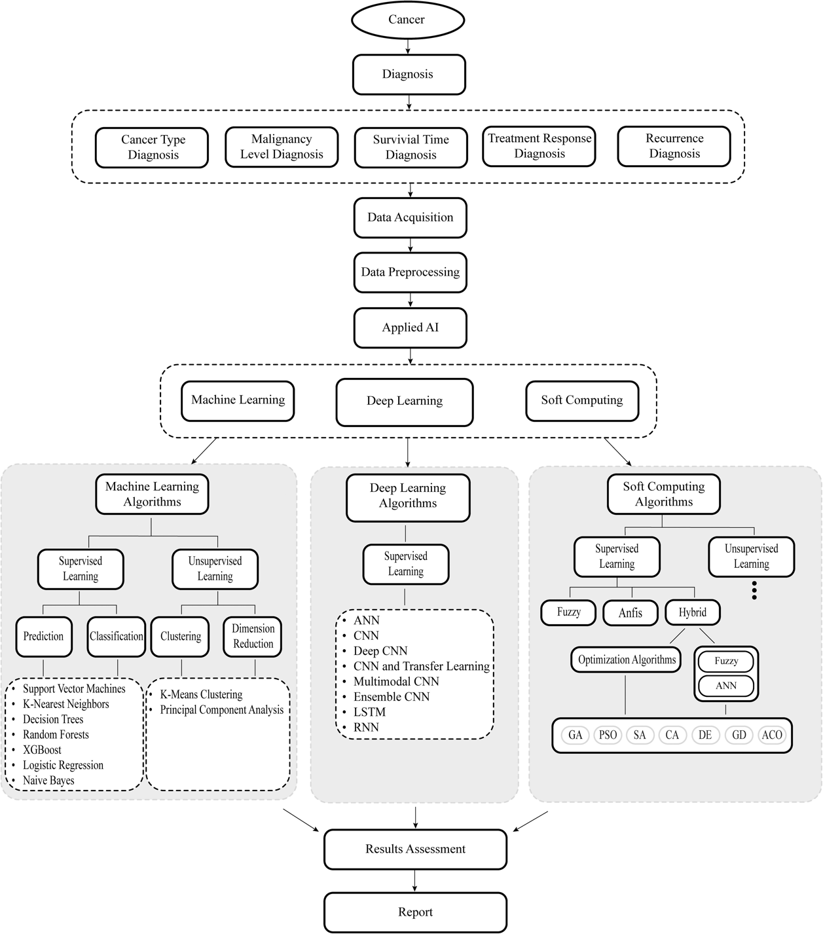

Figure 2.1: The workflow of AI in Cancer research (AI: artificial intelligence, XGBoost: eXtreme Gradient Boost, ANN: artificial neural network, CNN: convolutional neural network, LSTM: long short-term memory networks, RNN: recurrent neural network, Anfis: adaptive network-based fuzzy inference system.

Source: The Application of Artificial Intelligence to Cancer Research: A Comprehensive Guide (Gaur & Jagtap, 2022)

2.3.2 Predictive models for OSCC recurrence using ML
Multiple AI based predictive models for accurately forecasting recurrrence have been developed for several cancers which includes breast, prostate, colorectal and thyroid cancer (De Laurentiis et al., 1999; Ho et al., 2021; Marin & Casado, 2023; Wang et al., 2024) . They are proven to have superior predictive accuracy compared to traditional statistical approaches. Recurrence predictive model using ML was first introduced by De Laurentiis et al. (1999). They developed a prognostic model, by using few routinely evaluated prognostic variables such as patient age, tumor size, number of axillary metastases, oestrogen and progesterone receptor levels, S-phase fraction, and tumor ploidy among 310 breast cancer patients. From this study, the ANN discriminated patients according to their risk of recurrence better than the standard TNM classification (P = 0.0015)(De Laurentiis et al., 1999). Within each TNM class, the ML model obtained from this study can identify patients with remarkably diverse recurrence risks and discriminates prognosis more effectively than the TNM classification. Since then, research into the development of machine learning models for predicting recurrence has significantly expanded.
In the field of OSCC, several studies have also developed ML models to predict recurrence. For an example, Bourdillon et al. (2023), used patients demographic profile and clinicopathological factors as a data input for their ML model to predict the interval of oral cancer recurrence to ensure timely detection of LRR and metastasis of patients at risk. In addition to this data, they also used an externally validate nomogram by Gross et al. (2008) as their data input to evaluate its accuracy for clinical use. The ML algorithms used in their study were LR, DT, SVM and ANN, with DT and the SVM models showing the highest accuracy of 80.8% (Bourdillon et al., 2023). Besides this, Fatapour et al. (2023), has also recently worked on developing a predictive model for recurrence oral tongue squamous cell carcinoma (OTSCC). They developed ML models that predicted 5‑ and 10‑year cancer recurrence using the following demographic and clinical variables of interest; age, sex, race, marital status, year of diagnosis, the number of prior tumours, tumour site (e.g., ventral surface of the tongue, dorsal surface of the tongue, border of the tongue). The ML algorithms used in this study were different compared to the earlier one which is Generalized Linear Model (GLM), Gradient Boosting Machine (GBM), Distributed Random Forest (DRF), and deep learning (artificial neural network).Of those, GBM‑based model showed the highest accuracies of 82% and 80% for 5‑year and 10‑year recurrence, respectively. With growing use of AI in this field, this tool can have substantial implications in future oncologic research with a prime aim towards improving disease management and optimizing patient outcomes (Fatapour et al., 2023).

CHAPTER 3: METHODOLOGY

3.1 Study type and Study population
This retrospective multicentre study involves surgically treated OSCC cases from the Department of Oral and Maxillofacial Surgery, Hospital Tengku Ampuan Rahimah (HTAR), Klang, the Oral Surgery Clinic, Department of Oral and Maxillofacial Clinical Sciences, Faculty of Dentistry, University Malaya (UM), and the Department of Oral and Maxillofacial Surgery, Hospital Kuala Lumpur (HKL). The cases reviewed will cover the period from 2005 to April 2023. During this period, a total of 380 cases were obtained from the HTAR and UM databases, which will serve as the primary dataset for this study. These cases were originally collected as part of a previous study conducted during the MOSc program last year.
3.2 Sampling Method
Convenience sampling method will be used, whereby patients that satisfy the predefined criteria will be included in this study. The following are the inclusion and the exclusion criterions.
Inclusion Criteria:
i. Primary OSCC cases with tumours located in the oral cavity and confirmed histopathologically.
ii. Cases treated surgically with curative intent, with or without postoperative chemotherapy or radiotherapy.
iii. Patients with a minimum follow-up of 36 months and more than 6 months after primary surgery.
iv. Patients with complete sociodemographic, clinicopathological and follow-up data.

Exclusion Criteria:
i. Patients diagnosed with malignancies other than OSCC.
ii. Cases where patients underwent pre-operative chemotherapy or radiotherapy.
iii. Patients with subsequent tumour developed within 6 months post-operatively.
- Cases with missing or incomplete sociodemographic, clinicopathological and follow-up data.

3.3 Data handling
To ensure patient confidentiality, all identifiable information will be anonymized. Specifically, patient names or other personal identifiers will not be extracted or recorded. Each sample will be assigned a laboratory reference number, which will be used throughout the research process. This reference number will be used to link samples to the corresponding clinical data, without revealing the identity of the patient. All patient related information’s will be stored on a password-protected laptop and hard-disk that can only be assessed by the principal investigator and co-investigators.
3.4 OSCC recurrence and recurrence interval
Recurrence of OSCC in this study will include all cases with; (1) LR- recurrence at the same anatomical site after 6 months and within 5 years after primary curative intended treatment; (2) LRR- arising in both the primary site and neck site after 6 months and within 5 years after primary curative intended treatment; (3) RR - lymph node metastasis of the neck after 6 months and within 5 years after primary curative intended treatment; (4) second primary tumour of the oral cavity- carcinoma that developed at the anatomical site 3cm away from the primary tumour after 6 months and within 5 years after primary curative intended treatment or recurrence at the same anatomical site 5 years after primary treatment (Blatt et al., 2022; Rohde et al., 2020;Yanamoto et al., 2012). Recurrence cases will be categorized into two groups which is early recurrence, occurring between 6 to 24 months, and late recurrence, occurring after 25 months.
3.5 Identification of the sociodemographic, clinicopathological factors that is associated with OSCC recurrence.
The socio-demographic and the clinicopathological data for this study are primarily sourced from the dataset collected in the previous study. As a continuation, the current research aims to gather the missing, incomplete sociodemographic and clinical data as well as follow-up data from i-pesakit (for patients treated in Universiti Malaya Medical Centre, UMMC) and patients records for the Department of Oral and Maxillofacial Surgery (OMFS), Hospital Tengku Ampuan Rahimah, Klang. Additional data will be collected from the Department of Oral and Maxillofacial Surgery (OMFS) at Hospital Kuala Lumpur (HKL) to serve as the test set for the machine learning recurrence predictive model. Similarly, the data will be retrieved from histopathological reports and patients’ case notes. Follow-up time is defined from the date of the initial diagnosis documented on the pathological report until either the date of death or the last clinical follow-up as recorded in the files (Ghantous et al., 2018). Patients who do not experience recurrence during the follow-up period will be censored at their last documented follow-up date, confirming their recurrence free status. Formalin fixed paraffin embedded (FFPE) tissue blocks for cases included in this study will be retrieved from Diagnostic Oral Pathology Unit and Malaysian Oral Cancer Database and Tissue Bank System (MOCBTS) and Oral Pathology Unit under OMFS department, HKL. These FFPE tissues will be used for immunohistochemical study and assessment of the incomplete histopathological data. Univariate will be used to identify sociodemographic and clinicopathological factors that are associated with OSCC recurrence. Variables with a p-value under 0.25 will be chosen as data input for the ML model development (Bursac et al., 2008). The high p-value in the first step will be chosen to ensure that potentially important variables are not prematurely excluded.
3.6 Evaluation of EGFR, p53, and Ki67 marker expression in recurrence and non-recurrence OSCC cases.
To identify if the expression of EGFR, p53, and Ki67 could predict OSCC recurrence, the immunohistochemical expression of these markers in the primary tumour will be assessed and its association with OSCC recurrence will be determined by using Pearson Chi-square test and Fisher's Exact test.
3.6.1 Sample size calculation for Immunohistochemistry analysis.
Based on the effect size of 0.902 and power of 82.19%, the estimated sample size was 22 cases for each group. This estimation is obtained from the data gathered from our previous study using the same population. However, the sample size will be calculated again once the number of OSCC recurrences have been finalized. The control group will be comprised of OSCC cases diagnosed during the same period but did not develop any recurrence in the subsequent three years of follow up. Selection of these cases were strictly based on the same inclusion and exclusion criteria as listed above.
3.6.2 Immunohistochemistry and scoring
Immunohistochemistry (IHC) staining using anti-EGFR, anti-Ki67 and anti-p53 antibodies will be performed on the selected FFPE oral cancer tissues according to the manufacturer’s protocol. In the immunohistochemistry analysis of p53, the staining patterns were classified into four distinct categories to assess p53 expression status(Osakabe, Yamada et al. 2024). If the nuclear staining was observed with uniformly strong, diffuse nuclear expression in at least 80% of tumor cells (regardless of whether cytoplasmic staining was present), the staining pattern was classified as “p53 overexpression pattern”. No p53 staining (complete absence of any nuclear expression) was termed as “null pattern”. Next, if cytoplasmic staining was present in cases in which the nuclear staining did not meet the criteria for the p53 overexpression pattern or p53 null pattern, the case was classified as “p53 cytoplasmic pattern”. Finally, a staining pattern that did not meet any of the above criteria (weak staining pattern of nuclear or cytoplasmic staining), was classified as “p53 wild-type pattern”.
For evaluation of EGFR, both membranous and cytoplasmic staining will be evaluated. The intensity of staining will be classified as: no staining (0), weak (1+), intermediate (2+), and strong (3+). The percentage of positively stained cells will be simultaneously counted. Intermediate to strong staining in > 10% of tumour cells will be considered as strong positive while weak to intermediate staining in < 10% of cancer cells will be categorized as weak positive (Hashmi et al., 2018). Ki-67 labelling index (LI) is derived as number positive cells for Ki67 multiplied by 100 and divided by total number observed neoplastic epithelial cells and three different fields will be examined for each case. The median proportion will be used as a cutoff for further analysis of high and low Ki-67 LI groups (Jing et al., 2018).

3.7 Development of a machine learning model to predict OSCC recurrence
The dataset for the machine learning model will be divided into four input sets, as illustrated in Figure 1. The first input set includes all cases with complete sociodemographic and clinicopathological data. The second input set, labelled as "feature selection," includes variables with a p-value of less than 0.25 based on the univariate analysis. The third and fourth input sets focus specifically on cases with complete sociodemographic and clinicopathological data with and without the expression levels of EGFR, Ki-67, and p53 markers. For all the groups, the development of a machine learning model to predict OSCC recurrence will involve dividing the cases into two datasets: a training set (80%) and a validation (20%) (Barak Or, 2023) (Figure 2). Several commonly used machine learning algorithms based on the current literature review will be used for model development, such as logistic regression (LR) random forest (RF), Decision Tree (DT) and support vector machines (SVM). K-fold cross-validation (e.g., 5-fold or 10-fold) will be applied to minimize overfitting during training. The training set will be used to build the model, which will then be fine-tuned using the validation set. The test set which is 20% to 30% of the training set will be derived from the HKL OSCC patients and will serve as an independent dataset to assess the model's predictive performance (Figure 2). Key metrics, such as accuracy, sensitivity, specificity, precision, F1-score, and area under the ROC curve (AUC), for each model will be reported and compared (Figure 1). All Statistical analyses will be performed using SPSS, while the machine learning models will be analysed using Python (e.g., scikit-learn library, keras, and tensorflow packages).

Expected Results/Benefit

- Novel theories/New findings/Knowledge:
This study will introduce a machine learning-based predictive model for OSCC recurrence which will offer clinicians new insights into how sociodemographic, clinicopathological and immunohistochemical data can be integrated to predict recurrence and improve overall prognosis of OSCC patients.
- Research publications:
We aim to publish this research in an establish journal.

- Specific or Potential Applications:

The ultimate goal is to deploy this model as a predictive tool for OSCC patients treated at Universiti Malaya Medical Centre (UMMC) whose clinical, histopathological and follow-up data are stored in the Oral Cancer Research & Coordinating Center, University of Malaya (OCRCC-UM)

APPENDIX A
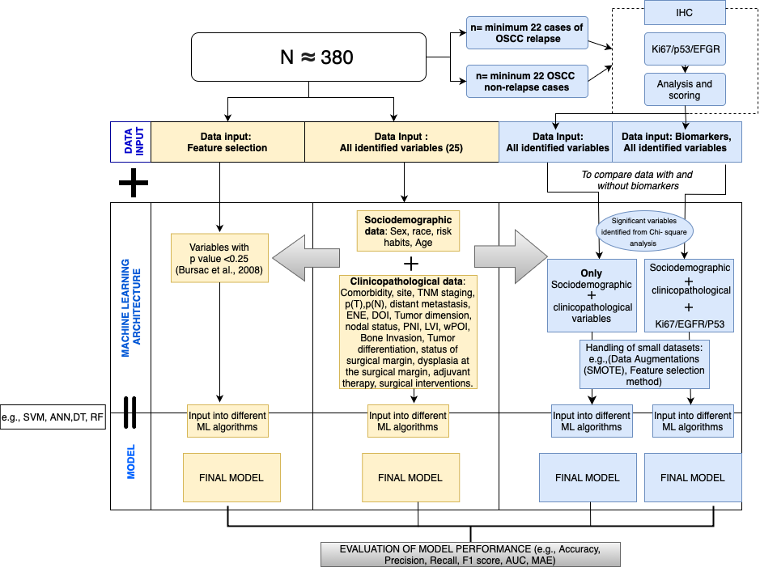
Figure 1: Workflow of development of the machine learning predictive model

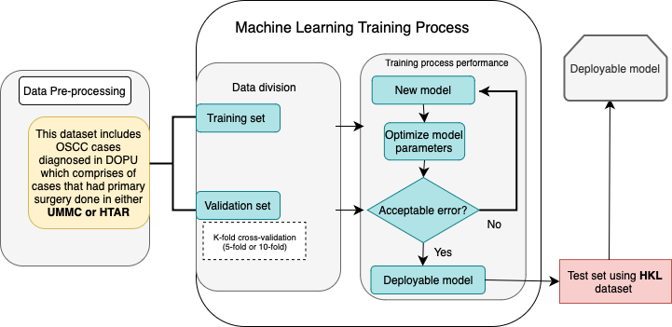
Figure 2: Machine learning training scheme

Proposed Gantt Chart & Key Milestones

References

Adriaansens, C., Noorlag, R., Visscher, W. P., de Bree, R., Breimer, G. E., & van Es, R. J. J. (2023). A closer look at the resection margins of buccal mucosa cancer: Their influence on local recurrence free survival. Head Neck, 45(4), 983-992. https://doi.org/10.1002/hed.27322
Azizah AM., H. B., Nirmal K., Siti Zubaidah AR., Puteri NA., Nabihah A., Sukumaran R., Balqis B.,, & Nadia SMR., S. S., Rahayu O., Nur Alham O., Azlina AA. (2019). Malaysia National Cancer Registry (MNCR) (5 ed.). https://www.moh.gov.my/moh/resources/Penerbitan/Laporan/Umum/2012-2016%20(MNCRR)/MNCR_2012-2016_FINAL_(PUBLISHED_2019).pdf
Amin, M. B., Greene, F. L., Edge, S. B., Compton, C. C., Gershenwald, J. E., Brookland, R. K., Meyer, L., Gress, D. M., Byrd, D. R., & Winchester, D. P. (2017). The Eighth Edition AJCC Cancer Staging Manual: Continuing to build a bridge from a population-based to a more "personalized" approach to cancer staging. CA Cancer J Clin, 67(2), 93-99. https://doi.org/10.3322/caac.21388
Awawdeh, M. A., Sasikumar, R., Aboalela, A. A., Siddeeqh, S., Gopinathan, P. A., Sawair, F., & Khanagar, S. B. (2023). Evaluation of Prognostic Significance of the Expression of p53, Cyclin D1, EGFR in Advanced Oral Squamous Cell Carcinoma after Chemoradiation—A Systematic Review. Applied Sciences, 13(9), 5292. https://www.mdpi.com/2076-3417/13/9/5292
Balachandran, V. P., Gonen, M., Smith, J. J., & DeMatteo, R. P. (2015). Nomograms in oncology: more than meets the eye. Lancet Oncol, 16(4), e173-180. https://doi.org/10.1016/s1470-2045(14)71116-7
Blatt, S., Krüger, M., Sagheb, K., Barth, M., Kämmerer, P. W., Al-Nawas, B., & Sagheb, K. (2022). Tumor Recurrence and Follow-Up Intervals in Oral Squamous Cell Carcinoma. J Clin Med, 11(23). https://doi.org/10.3390/jcm11237061
Bourdillon, A. T., Shah, H. P., Cohen, O., Hajek, M. A., & Mehra, S. (2023). Novel Machine Learning Model to Predict Interval of Oral Cancer Recurrence for Surveillance Stratification. Laryngoscope, 133(7), 1652-1659. https://doi.org/10.1002/lary.30351
Bray F, L. M., Sung H, Ferlay J, Siegel RL, Soerjomataram I, Jemal A. (2024.). Global cancer statistics 2022: GLOBOCAN estimates of incidence and mortality worldwide for 36 cancers in 185 countries. CA Cancer J Clin., 74.(3.), 229-263. https://doi.org/10.3322/caac.21834.
Camisasca, D. R., Silami, M. A., Honorato, J., Dias, F. L., de Faria, P. A., & Lourenço Sde, Q. (2011). Oral squamous cell carcinoma: clinicopathological features in patients with and without recurrence. ORL J Otorhinolaryngol Relat Spec, 73(3), 170-176. https://doi.org/10.1159/000328340
Can artificial intelligence help see cancer in new ways?-NCI. Retrieved October 25, 2024 from https://www.cancer.gov/news-events/cancer-currents-blog/2022/artificial-intelligence-cancer-imaging
Chung, E. J., Park, M. W., Kwon, K. H., & Rho, Y. S. (2020). Clinical outcomes and prognostic factor analysis after salvage surgery for recurrent squamous cell carcinoma of the oral cavity. Int J Oral Maxillofac Surg, 49(3), 285-291. https://doi.org/10.1016/j.ijom.2019.03.967
Cívico-Ortega, J. L., González-Ruiz, I., Ramos-García, P., Cruz-Granados, D., Samayoa-Descamps, V., & González-Moles, M. (2023). Prognostic and Clinicopathological Significance of Epidermal Growth Factor Receptor (EGFR) Expression in Oral Squamous Cell Carcinoma: Systematic Review and Meta-Analysis. Int J Mol Sci, 24(15). https://doi.org/10.3390/ijms241511888
Davaatsend, O., Altannamar, M., Ganbat, M., & Jagdagsuren, U. (2024). Factors associated with recurrence in patients with oral cancer in Mongolia. BMC Cancer, 24(1), 356. https://doi.org/10.1186/s12885-024-12118-8
De Laurentiis, M., De Placido, S., Bianco, A. R., Clark, G. M., & Ravdin, P. M. (1999). A prognostic model that makes quantitative estimates of probability of relapse for breast cancer patients. Clin Cancer Res, 5(12), 4133-4139.
Dong, L., Xue, L., Cheng, W., Tang, J., Ran, J., & Li, Y. (2024). Comprehensive survival analysis of oral squamous cell carcinoma patients undergoing initial radical surgery. BMC Oral Health, 24(1), 919. https://doi.org/10.1186/s12903-024-04690-z
Faisal, M., Abu Bakar, M., Sarwar, A., Adeel, M., Batool, F., Malik, K. I., Jamshed, A., & Hussain, R. (2018). Depth of invasion (DOI) as a predictor of cervical nodal metastasis and local recurrence in early stage squamous cell carcinoma of oral tongue (ESSCOT). PLoS One, 13(8), e0202632. https://doi.org/10.1371/journal.pone.0202632
Fatapour, Y., Abiri, A., Kuan, E. C., & Brody, J. P. (2023). Development of a Machine Learning Model to Predict Recurrence of Oral Tongue Squamous Cell Carcinoma. Cancers (Basel), 15(10). https://doi.org/10.3390/cancers15102769
Gaur, K., & Jagtap, M. M. (2022). Role of Artificial Intelligence and Machine Learning in Prediction, Diagnosis, and Prognosis of Cancer. Cureus, 14(11), e31008. https://doi.org/10.7759/cureus.31008
Gerdes, J., Lemke, H., Baisch, H., Wacker, H. H., Schwab, U., & Stein, H. (1984). Cell cycle analysis of a cell proliferation-associated human nuclear antigen defined by the monoclonal antibody Ki-67. J Immunol, 133(4), 1710-1715.
Ghani, W. M. N., Razak, I. A., Doss, J. G., Yang, Y.-H., Rahman, Z. A. A., Ismail, S. M., Abraham, M. T., Wan Mustafa, W. M., Tay, K. K., & Zain, R. B. (2019). Multi-ethnic variations in the practice of oral cancer risk habits in a developing country. Oral Diseases, 25(2), 447-455. https://doi.org/https://doi.org/10.1111/odi.12995
Ghanizada, M., Jakobsen, K. K., Jensen, J. S., Wessel, I., Filtenborg Tvedskov, J., Grønhøj, C., & von Buchwald, C. (2021). The impact of comorbidities on survival in oral cancer patients: a population-based, case-control study. Acta Oncol, 60(2), 173-179. https://doi.org/10.1080/0284186x.2020.1836393
Ghantous, Y., Bahouth, Z., & Abu El-Naaj, I. (2018). Clinical and genetic signatures of local recurrence in oral squamous cell carcinoma. Arch Oral Biol, 95, 141-148. https://doi.org/10.1016/j.archoralbio.2018.07.018
Gross, N. D., Patel, S. G., Carvalho, A. L., Chu, P. Y., Kowalski, L. P., Boyle, J. O., Shah, J. P., & Kattan, M. W. (2008). Nomogram for deciding adjuvant treatment after surgery for oral cavity squamous cell carcinoma. Head Neck, 30(10), 1352-1360. https://doi.org/10.1002/hed.20879
Gupta, S., Kushwaha, V. S., Verma, S., Khan, H., Bhatt, M. L. B., Husain, N., Negi, M. P. S., Bhosale, V. V., & Ghatak, A. (2016). Understanding molecular markers in recurrent oral squamous cell carcinoma treated with chemoradiation. Heliyon, 2(12), e00206. https://doi.org/https://doi.org/10.1016/j.heliyon.2016.e00206
Ho, D., Tan, I. B. H., & Motani, M. (2021). Predictive models for colorectal cancer recurrence using multi-modal healthcare data Proceedings of the Conference on Health, Inference, and Learning, Virtual Event, USA. https://doi.org/10.1145/3450439.3451868
Jing, D. Y., Zhou, D. Q., Zhu, D. H., Zhang, M. Y., Song, D. Y., Xiaoxin, D. Z., Huang, P. X., Yang, M. Y., Ni, D. Y., & Hu, P. Q. (2019). KI67 IS AN INDEPENDENT PROGNOSTIC MARKER FOR RECURRENCE AND RELAPSE IN ORAL SQUAMOUS CELL CARCINOMA PATIENTS. Oral Surgery, Oral Medicine, Oral Pathology and Oral Radiology, 128(1), e76. https://doi.org/10.1016/j.oooo.2019.02.188
Kim, D. W., Lee, S., Kwon, S., Nam, W., Cha, I. H., & Kim, H. J. (2019). Deep learning-based survival prediction of oral cancer patients. Sci Rep, 9(1), 6994. https://doi.org/10.1038/s41598-019-43372-7
Leemans, C. R., Braakhuis, B. J., & Brakenhoff, R. H. (2011). The molecular biology of head and neck cancer. Nat Rev Cancer, 11(1), 9-22. https://doi.org/10.1038/nrc2982
Lenze, N. R., Farquhar, D. R., Dorismond, C., Sheth, S., Zevallos, J. P., Blumberg, J., Lumley, C., Patel, S., Hackman, T., Weissler, M. C., Yarbrough, W. G., Olshan, A. F., & Zanation, A. M. (2020). Age and risk of recurrence in oral tongue squamous cell carcinoma: Systematic review. Head & Neck, 42(12), 3755-3768. https://doi.org/https://doi.org/10.1002/hed.26464
Li, Z., Ding, S., Zhong, Q., Fang, J., Huang, J., Huang, Z., & Zhang, Y. (2023). A machine learning model for predicting the three-year survival status of patients with hypopharyngeal squamous cell carcinoma using multiple parameters. J Laryngol Otol, 137(9), 1041-1047. https://doi.org/10.1017/s0022215123000063
Lin, T. Y.-Y., Liu, K. Y. P., Novack, R., Mattu, P. S., Ng, T. L., Hoang, L. N., Prisman, E., Poh, C. F., & Ko, Y. C. K. (2024). Abnormal p53 Immunohistochemical Patterns Are Associated with Regional Lymph Node Metastasis in Oral Cavity Squamous Cell Carcinoma at Time of Surgery. Modern Pathology, 37(12), 100614. https://doi.org/https://doi.org/10.1016/j.modpat.2024.100614
Liu, Y., Liu, L., He, Y., Jiang, W., Fang, T., Huang, Y., Zhou, X., Zhu, D., Li, J., & Zhong, L. (2024). Nomogram to Predict Nodal Recurrence-Free Survival in Early Oral Squamous Cell Carcinoma. Oral Dis. https://doi.org/10.1111/odi.15141
Marin, L., & Casado, F. (2023). Prediction of prostate cancer biochemical recurrence by using discretization supports the critical contribution of the extra-cellular matrix genes. Scientific Reports, 13(1), 10144. https://doi.org/10.1038/s41598-023-35821-1
Monteiro, L. S., Diniz-Freitas, M., Garcia-Caballero, T., Forteza, J., & Fraga, M. (2010). EGFR and Ki-67 expression in oral squamous cell carcinoma using tissue microarray technology. J Oral Pathol Med, 39(7), 571-578. https://doi.org/10.1111/j.1600-0714.2009.00876.x
Puteri, A., & Meizarini, A. (2020). p53: The guardian of genome against OSCC progression. European Journal of Molecular and Clinical Medicine, 7, 1071-1079.
Qiu, L., Khormali, A., & Liu, K. (2023). Deep Biological Pathway Informed Pathology-Genomic Multimodal Survival Prediction. arXiv:2301.02383. Retrieved January 01, 2023, from https://ui.adsabs.harvard.edu/abs/2023arXiv230102383Q
Solomon, M. C., Vidyasagar, M. S., Fernandes, D., Guddattu, V., Mathew, M., Shergill, A. K., Carnelio, S., & Chandrashekar, C. (2016). The prognostic implication of the expression of EGFR, p53, cyclin D1, Bcl-2 and p16 in primary locally advanced oral squamous cell carcinoma cases: a tissue microarray study. Medical Oncology, 33(12), 138. https://doi.org/10.1007/s12032-016-0851-8
Sung, H., Ferlay, J., Siegel, R. L., Laversanne, M., Soerjomataram, I., Jemal, A., & Bray, F. (2021). Global Cancer Statistics 2020: GLOBOCAN Estimates of Incidence and Mortality Worldwide for 36 Cancers in 185 Countries. CA Cancer J Clin, 71(3), 209-249. https://doi.org/10.3322/caac.21660
Veeraraghavan, V. P., Daniel, S., Dasari, A. K., Aileni, K. R., patil, C., & Patil, S. R. (2024). Emerging targeted therapies in oral oncology: Focus on EGFR inhibition. Oral Oncology Reports, 11, 100592. https://doi.org/https://doi.org/10.1016/j.oor.2024.100592
Vollmer, A., Hartmann, S., Vollmer, M., Shavlokhova, V., Brands, R. C., Kübler, A., Wollborn, J., Hassel, F., Couillard-Despres, S., Lang, G., & Saravi, B. (2024). Multimodal artificial intelligence-based pathogenomics improves survival prediction in oral squamous cell carcinoma. Scientific Reports, 14(1), 5687. https://doi.org/10.1038/s41598-024-56172-5
Wang, B., Zhang, S., Yue, K., & Wang, X. D. (2013). The recurrence and survival of oral squamous cell carcinoma: a report of 275 cases. Chin J Cancer, 32(11), 614-618. https://doi.org/10.5732/cjc.012.10219
Wang, H., Zhang, C., Li, Q., Tian, T., Huang, R., Qiu, J., & Tian, R. (2024). Development and validation of prediction models for papillary thyroid cancer structural recurrence using machine learning approaches. BMC Cancer, 24(1), 427. https://doi.org/10.1186/s12885-024-12146-4
Wang, Y., Yang, T., Gan, C., Wang, K., Sun, B., Wang, M., & Zhu, F. (2023). Temporal and spatial patterns of recurrence in oral squamous cell carcinoma, a single-center retrospective cohort study in China. BMC Oral Health, 23(1), 679. https://doi.org/10.1186/s12903-023-03204-7
WHO. (2022). WHO Classification of Tumours Editorial Board. Head and neck tumours. Lyon (France): International Agency for Research on Cancer; 2022. (Vol. 9). International Agency for Research on Cancer. https://tumourclassification.iarc.who.int/chapters/52
Yanamoto, S., Yamada, S., Takahashi, H., Yoshitomi, I., Kawasaki, G., Ikeda, H., Minamizato, T., Shiraishi, T., Fujita, S., Ikeda, T., Asahina, I., & Umeda, M. (2012). Clinicopathological risk factors for local recurrence in oral squamous cell carcinoma. Int J Oral Maxillofac Surg, 41(10), 1195-1200. https://doi.org/10.1016/j.ijom.2012.07.011
Zhang, B., Shi, H., & Wang, H. (2023). Machine Learning and AI in Cancer Prognosis, Prediction, and Treatment Selection: A Critical Approach. J Multidiscip Healthc, 16, 1779-1791. https://doi.org/10.2147/jmdh.S410301
Zuo, D., Yang, L., Jin, Y., Qi, H., Liu, Y., & Ren, L. (2023). Machine learning-based models for the prediction of breast cancer recurrence risk. BMC Med Inform Decis Mak, 23(1), 276. https://doi.org/10.1186/s12911-023-02377-z

